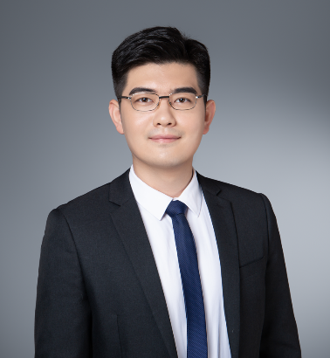

**Liu Chuanlong Associate**

**Expertise：Dispute Resolution, Construction and Real Estate, Labor Employmen**

**Tel：+86 10 8587 0068**

**Fax：+86 10 8587 0079**

**Email：chuanlong.liu@chancebridge.com**

**Areas of Practice**

Liu Chuanlong is a lawyer at Chance Bridge Law Firm, mainly engaged in civil and commercial dispute resolution, construction and real estate.

**Education background**

* LL.M, Law School, The University of Sydney
* LL.B, Law School, Renmin University of China

**Work Experience**

* Chance Bridge Law Firm Associate
* ANLI Partners Associate
* TAHOTA Law Firm Paralegal‌

**Representative Matters**

**Dispute Resolution**

* Acting for DONGYA XINHUA Investment Group in a series of construction and real estate disputes;
* Acting for GREENTOWN Group in a series of construction and real estate disputes;
* Acting for HAWTAI MOTOR Group in a series of financial loan disputes;
* Acting for CGWIC in an equity transfer constract dispute;
* Acting for Borun Real Estate Co., Ltd in a land lease contract dispute.

**Legal Counsel**

Taiwan Affairs Office of the State Council, Aluminum Corporation of China, China Communications Construction, China Development Bank, China Quality Mark Certification Group, Beijing Kuntai Group, GREENTOWN Group, DONGYA XINHUA Investment Group, etc.

**Language**

Chinese, English